**By faith we understand that the universe**

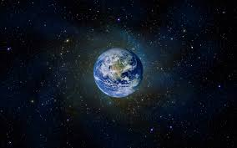

**Was formed by**

**God’s command**



**So that what is seen was not made out of what was visible.**

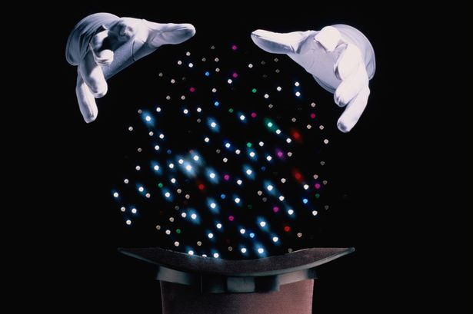

**Says Hebrews 11:3**