I put print this out and cut it out so it will fit on a 3 x 5 index card. The images are clip art I found on the internet.

Trust in the Lord with all your 

and do 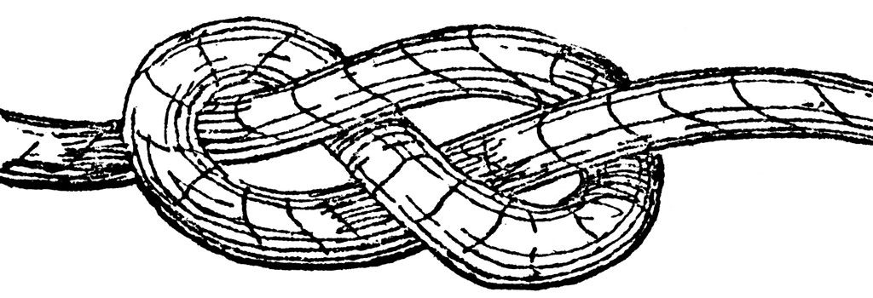  on your own 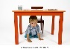 Image result for child standing free clipart. (UNDER the table, STANDING up = understanding

In all your ways acknowledge Him, Acknowledge may need to be defined.

and He will 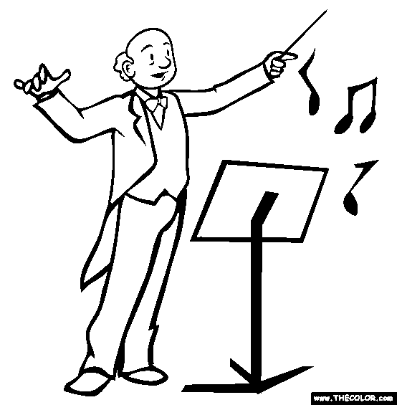 your .

Provers 3:5-6